Introduction
Microwave methods and technology have made significant advances since their introduction. Microwave radiation was first used to affect rapid tissue heating resulting in structural stabilization (Mayer, 1970).
It has since been applied to the processing steps for electron microscopy, paraffin embedding, immunolabeling, in situ hybridization, histological stains, epitope retrieval and reducing the time required for bone decalcification with EDTA. Microwave-mediated chemical fixation has demonstrated improved results over classical bench methods.
Fixation, processing, staining and immunolabeling have benefited from the use of microwave radiation through significant reductions in processing times and improved results (Wendt et al. 2004; Tinling et al. 2004; Giberson et al. 2003; Gerrity and Forbes 2003; Galvez et al. 2004; Buchanan 2004).
It is also evident from the cited research that microwave radiation independent of microwave heating plays a significant role in the process. Improved technology has shown that control of the microwave processing environment is a key to reproducibility and quality results. The site is devoted to a better understanding of microwave energy and its potential as the new processing medium of the 21st century.
Microwave processing protocol for electron microscopy using the PELCO BioWave® Laboratory Tissue Processing System
The following protocol submitted by Richard Giberson, Manager R&D, Ted Pella, Inc., is an evolution of microwave processing methods over the last ten years and is intended to be a good general protocol which yields consistent results for a wide range of tissues.

- Aldehyde Fixation
  - Glutaraldehyde
    - For fresh tissue
Step | Continuous power | Time sequence | Vacuum
1 | 150 W | 1 min on, 1 min off, 1 min on | 20 in Hg
    - For tissue received in fixative
Step | Continuous power | Time sequence | Vacuum
1 | 150 W | 10 sec on, 20 sec off, 10 sec on | 20 in Hg
  - Karnovsky's Fixative (Glutaraldehyde + paraformaldehyde)
    - For fresh tissue
Step | Continuous power | Time sequence | Vacuum
1 | 150 W | 1 min on, 1 min off, 1 min on | 20 in Hg
2 | 650 W | 10 sec on, 20 sec off, 10 sec on | 20 in Hg
    - For tissue received in fixative
Step | Continuous power | Time sequence | Vacuum
1 | 650 W | 10 sec on, 20 sec off, 10 sec on | 20 in Hg

Notes
Formaldehyde (paraformaldehyde) either mixed with glutaraldehyde or used alone requires a two-step process for fixation (shown above) when starting fresh tissue. Step 1 promotes the infiltration of the fixative and Step 2 the binding of the fixative to the tissue. For tissues received in fixative, the infiltration step is considered to be complete, therefore, only Step 2 is necessary.
Sample processing can be done in microcentrifuge tubes, multi-well plates, glass or plastic vials, 6 or 12-well PELCO Prep-Eze™ tissue holders or similar types of vessels. See Figure 1 for the setup inside the microwave cavity. The temperature probe is used to check the temperature of the fixative solution after processing has been completed and is left in the PELCO ColdSpot® during the time the microwave is on. The times and wattages listed for fixation ensure that the final solution temperatures remain below 40°C after completion of any given step. It is best to start with the fixative solutions at room temperature.

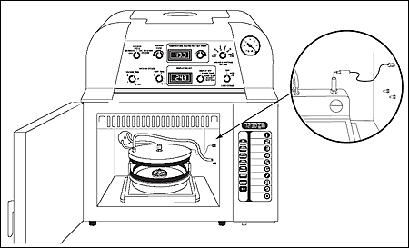
Figure 1: 36158-1 PELCO Prep-Eze™ 6-well Holder in a 36135 Polypropylene Petri Dish used with the 3435 PELCO® EM Microwave Vacuum Chamber on the 36115 PELCO ColdSpot®

References
Giberson RT, Elliot DE (2001) Microwave-assisted formalin fixation of fresh tissue: A comparitive study. In Giberson RT, Demaree RSJr, eds. Microwave Techniques and Protocols, Totowa, NJ, Humana Press, 191-208

- Buffer rinse
  - Outside the microwave
Two changes in fresh buffer for a total time of five minutes.
  - Or, using the microwave as in figure 2:
Rinse the sample in buffer, change to new buffer and:
Step | Continuous power | Time | Vacuum
1 | 250 W | 40 sec | None
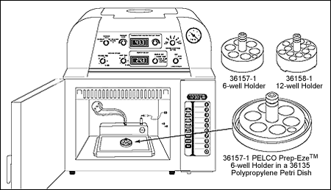
Figure 2: 36158-1 PELCO Prep-Eze™ 6-well Holder in a 36135 Polypropylene Petri Dish used directly on the 36115 PELCO ColdSpot®

- Osmium tetroxide fixation
Refer to figure 1 and use the following procedure:
Step | Continuous power | Time | Vacuum
1 | 80 W | 2 min on, 2 min off, 2 min on  Cool to 20 oC and repeat time sequence | Yes

Notes
  - Osmium is best used in concentrations of 1% or less. Aqueous works well and is our choice.
  - Reduced osium works well also (3% potassium ferricyanide mixed with an equal volume of 2% osmium just before use).
  - Higher concentrations of osmium will retard penetration of fixative into tissues in a microwave environment.

- Optional water rinse
This step is done to rinse the osmium from the processing vessel prior to starting dehydration. It is an optional step and it is up to the user to determine whether to go directly to the dehydration steps.

- Dehydration
Refer to figure 2, and do the following procedure:
Step | Solvent | Power | Time | Vacuum
1 | Ethanol or Acentone, 50% | 250 W | 40 sec | None
2 | Ethanol or Acentone, 70% | 250 W | 40 sec | None
3 | Ethanol or Acentone, 90% or 95% | 250 W | 40 sec | None
4 | Ethanol or Acentone, 100% | 250 W | 40 sec | None
5 | Ethanol or Acentone, 100% | 250 W | 40 sec | None

Notes
  - Acetone is our preference over ethanol for dehydration. Propylene oxide is not needed as a transition solvent.
  - If ethanol is used, the last 100% step can be done with acetone. Acetone works very well as a transition solvent.
  - A molecular sieve secured inside dialysis tubing will ensure a true 100% acetone or ethanol dehydration step.
  - A propylene oxide step can be added following dehydration for 45 seconds at 250W.

- Resin infiltration
Refer to figure 1 and do the following procedure:
Step | Resin mix | Power | Time | Vacuum
1 | Resin: 50%, Acetone: 50% | 250 W | 3 min | Yes
2 | Resin: 100% | 250 W | 3 min | Yes
3 | Resin: 100% | 250 W | 3 min | Yes

Notes
  - This infiltration series works well with a wide range of tissues.
  - Difficult tissues may require the addition of a 2:1 step and an added 100% step as well.

- Resin polymerization
Overnight in a convection oven, or referring to figure 3:
Step | Resin type | Power | Time | Vacuum
1 | Epoxy Resins - underwater | 80 W | 30 min | None
2 | Epoxy Resins - underwater | 650 W | 45 min | None
3 | LR White Resin - underwater | 80 W | 20 min | Yes
4 | LR White Resin - underwater | 650 W | 25 min | Yes
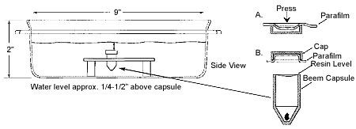
Figure 3: Resin polymerization under water

Notes
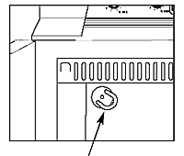
Figure 4: Capping ports with silicon
rubber tubing
  - Turn off the Load Cooler.
  - Remove the PELCO ColdSpot®.
  - Cap off the ports in the back of the microwave cavity with a short piece of silicon rubber tubing, as show in figure 4.
  - The resin is polymerized in BEEM-type capsules underwater as described below.
  - The low wattages at the beginning of resin polymerization control the initial heating rate. It should take about 20 min. to reach 60°C for the best polymerization.
  - The resin is polymerized in BEEM-type capsules underwater as described below.
  - The low wattages at the beginning of resin polymerization control the initial heating rate. It should take about 20 min. to reach 60°C for the best polymerization.

References
Giberson, R.T., Demaree, R.S., Jr., Nordhausen, R.W. Four-hour processing of clinical/diagnostic specimens for electron microscopy, Journal of Veterinary Diagnostic Investigation 9(1):61-67 (1997)

Relevant literature
Buchanan J. Microwave processing of Drosophila tissues for electron microscopy, Microscopy Today 12(6):42 (2004)
Glavez JJ, Giberson RT, Cardiff RD. Microwave mechanisms - the energy/heat dichotomy, Microscopy Today 12(2):18-23 (2004)
Gerrity RG, Forbes GW. Microwave processing in diagnostic electron microscopy, Microscopy Today 11(6):38-41 (2003)
Giberson RT, Demaree RS Jr, Nordhausen RW. Four-hour processing of clinical/diagnostic specimens for electron microscopy using microwave technique, Journal of Veterinary Diagnostic Investigation 9:61-67 (1997)
Giberson RT, Elliott DE. Microwave-assisted formalin fixation of fresh tissue: A comparative study, In Giberson RT, Demaree RS Jr, eds. Microwave Techniques and Protocols, Totowa, NJ, Humana Press, 191-208 (2001)
Giberson, R.T. Advances in microwave-assisted processing for electron microscopy, Microscopy and Microanalysis 7(Suppl.2):1192-1193 (2001)
Giberson, R.T., Demaree, R.S., Jr., Editors, Microwave Techniques and Protocols, Humana Press, Totawa, NJ. (2001)
Giberson RT, Austin RL, Charlesworth J, Adamson G, Herrera GA. Microwave and digital imaging technology reduce turnaround times for diagnostic electron microscopy, Ultrastruct Pathol 27:186-196 (2003)
Munoz TE, Giberson RT, Demaree R, Day JR. Microwave-assisted immunostaining: a new approach yields fast and consistent results, Journal of Neuroscience Methods 137(2):133-139 (2004)
Tinling S.P., Kular R. and Giberson R.T. Microwave assisted decalcification with recirculation of temperature controlled solutions, Microscopy and Microanalysis 8(Suppl.2):148-149. (2002)
Tinling SP, Giberson RT, Kullar RS. Microwave exposure increases bone demineralization rate independent of temperature, Journal of Microscopy 215(3):230-235 (2004)
Wendt KD, Jensen CA, Tindall R, Katz ML. Comparison of conventional and microwave-assisted processing of mouse retinas for transmission electron microscopy, Journal of Microscopy 214(1):80-88 (2004)

